BEHAVIOUR MANAGEMENT POLICY & PROCEDURES

Agreed: July 2025
Review: July 2026
Contents

Context 3
Roles and Responsibilities 3
Rewards 6
Sanctions 7
Registration and Punctuality Procedures 10
Procedures for lateness 11
Lateness to lessons 11
Restorative justice 11
Detentions 12
What does a detention look like? 13
Other sanctions for non-compliance or unacceptable behaviour: 13
Training 14
Inter-relationship with other school policies 14
Involvement of outside agencies 14
Policy Review 14
Search “without consent” 15
Exclusions 15
Reports 16

Context
In order to enable effective learning and teaching and for students to achieve their potential, the importance of excellence in behaviour in all aspects of school life is paramount. We seek to create a caring learning environment in the school by:

- providing a safe environment for students and staff to work in;
- cultivating excellent standards in behaviour and discipline;
- promoting self-esteem, self-discipline, a proper regard for authority and positive relationships based on mutual respect between everyone in the Fort Pitt community;
- encouraging equality and fair treatment for all;
- encouraging consistency of response to both positive and negative behaviour;
- promoting early and appropriate interventions in a supportive manner;
- promoting a culture of praise and encouragement in which all students can achieve;
- encouraging a positive relationship with parents and carers enabling them to play their part in the implementation of school policy and associated procedures;
- ensuring expectations of behaviour are clearly communicated to students, staff and parents
- promoting and encouraging the Fort Pitt Values in all aspects of school life (below is a diagram of the values)
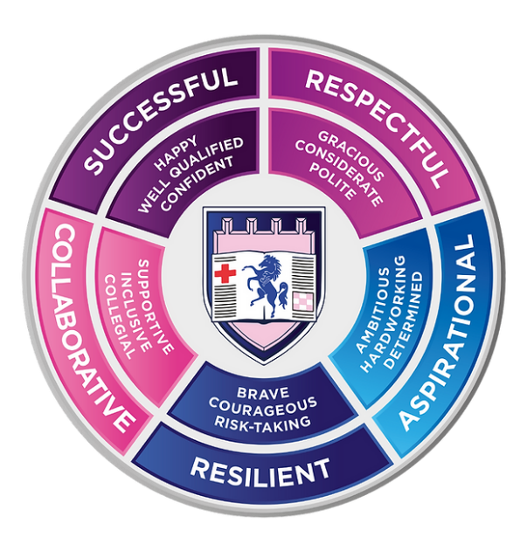

Roles and Responsibilities
Local Governing Body (LGB)
A formal review takes place every 2 years unless changes to legislation demand otherwise. This is communicated to students and parents/carers, is non-discriminatory and the expectations are clear. The LGB will support the school in maintaining high standards of behaviour. In practice this occurs at LGB meetings when analysing information presented or when a panel of LGB members reviews students who are at risk of suspension, as and if required.

Headteacher (and/or delegated representatives)
Responsibility for the implementation and day-to-day management of the policy and procedures along with supporting staff who may be faced with challenging behaviour.

School leaders
The school leadership team should be highly visible, with leaders routinely engaging with pupils, parents and staff on setting and maintaining the behaviour culture and an environment where everyone feels safe and supported. School leaders have a crucial role to play in making sure all staff understand the behavioural expectations and the importance of maintaining them. School leaders should make sure that all new staff are inducted clearly into the school’s behaviour culture to ensure they understand its rules and routines and how best to support all pupils to participate in creating the culture of the school.

Staff
Staff have an important role in developing a calm and safe environment for pupils and establishing clear boundaries of acceptable pupil behaviour. Staff should uphold the whole-school approach to behaviour by teaching and modelling expected behaviour and positive relationships, as defined by the school behaviour policy, so that pupils can see examples of good habits and are confident to ask for help when needed. Staff should also challenge pupils to meet the school expectations and maintain the boundaries of acceptable conduct. All staff should communicate the school expectations, routines, values and standards both explicitly through teaching behaviour and in every interaction with pupils. Staff should consider the impact of their own behaviour on the school culture and how they can uphold the school rules and expectations. Staff should also receive clear guidance about school expectations of their own conduct at school.

Students
All pupils deserve to learn in an environment that is calm, safe, supportive and where they are treated with dignity. To achieve this, every pupil will be made aware of the school behaviour standards, expectations, pastoral support, and consequence processes. Pupils will be taught that they have a duty to follow the school behaviour policy and uphold the school rules, and should contribute to the school’s ethos and values. Pupils will be asked about their experience of behaviour and given opportunity to provide feedback on the school’s behaviour culture through the school council. Every pupil will be supported to achieve the behaviour standards. Provision should be made for all new pupils to ensure they understand the school’s behaviour policy and wider culture. Students that join mid-year will be provided with school expectations at the earliest possible opportunity.

Parents and carers
Parents and carers share in the responsibility for the behaviour of their child both inside and outside the school, as set out in the home school agreement, agreed by every parent and carer. They have an important role in supporting the school’s behaviour policy and are encouraged to reinforce the policy at home as appropriate. The school will work in partnership with parents and carers to maintain high standards of behaviour and to raise any issues arising from the operation of these procedures.

Behaviour expectations for SEND students
Fort Pitt’s culture consistently promotes high standards of behaviour and provides the necessary support to ensure all pupils can achieve and thrive both in and out of the classroom. Our whole-school approach aims to meet the needs of all pupils in the school, including pupils with SEND, so that everyone can feel they belong in the school community and high expectations are maintained for all pupils. Behaviour will often need to be considered in relation to a pupil’s SEND, although it does not follow that every incident of misbehaviour will be connected to their SEND

Safeguarding
Consideration will be given where the behaviour under review gives cause to suspect that a child is suffering, or is likely to suffer, significant harm. Where this may be the case, school staff should follow the school’s safeguarding policy. They should also consider whether continuing disruptive behaviour might be the result of unmet educational or other needs. The school will consider whether multi-agency involvement is necessary.

Procedures
The procedures make clear to the students how acceptable standards of behaviour can be achieved and have a clear rationale which is made explicit to staff, students and parents/carers. The procedures will be consistently and fairly applied and promote the core values. Every member of the school has a responsibility towards the whole community.

Responding to good behaviour
Acknowledging good behaviour encourages repetition and communicates the school community’s expectations and values to all pupils. Using positive recognition and reward provides an opportunity for all staff to reinforce the school’s values as seen above. Positive reinforcements and reward should be applied clearly and fairly to reinforce the routines and expectations of the school’s behaviour culture.

Responding to misbehaviour
When a member of school staff becomes aware of misbehaviour, they should respond predictably, promptly, and assertively in accordance with the school behaviour policy. The first priority should be to ensure the safety of pupils and staff and to restore a calm environment. It is important that staff across a school respond in a consistent, fair, and proportionate manner so pupils know with certainty that misbehaviour will always be addressed. Staff will use a range of sanctions clearly defined by the school’s behaviour policy.

De-escalation techniques will be used to help prevent further behaviour issues arising and recurring and schools may use pre-agreed scripts and phrases to help restore calm. The aims of any response to misbehaviour should be to maintain the culture of the school, restore a calm and safe environment in which all pupils can learn and thrive, and prevent the recurrence of misbehaviour.

Rewards
A school ethos of praise and encouragement is central to the promotion of good behaviour. Rewards are one means of achieving this. They have a motivational role in helping students to realise that good behaviour is valued and clearly defined in the procedures. Integral to the system of rewards is an emphasis on praise and encouragement, both informal and formal, to individuals and groups alongside the behaviour points structure which contribute to overall house points and the winning of the House annual competition. All rewards in the school are linked to the school’s ethos and the Fort Pitt values.

Level of achievement | Achievement | Fort Pitt Value | Points
1 | Being helpful around school/in lessons | Demonstrating Respectful and Collaborative behaviour | 1
1 | Effort for homework | Demonstrating Aspirational behaviour | 1
1 | Excellent participation in lessons | Demonstrating Aspirational, Successful and Resilient behaviour | 1
1 | Attempting extension work | Demonstrating Aspirational behaviour | 1
1 | Completing all classwork to the best of your ability | Demonstrating Aspirational and Successful behaviour | 1
1 | Excellent pair/group work during the course of the lesson | Demonstrating Collaborative behaviour | 1
1 | Not giving up on a difficult/challenging task | Demonstrating Resilient behaviour | 1
1 | Being polite and considerate of peers/staff | Demonstrating Respectful behaviour | 1
1 | Excellent effort in class | Demonstrating Aspirational, Resilient and Successful behaviour | 1
1 | Demonstrated good reflective skills | Demonstrating Successful and Aspirational behaviour | 1
1 | Being kind | Demonstrating Collaborative and Respectful behaviour | 1
2 | Participating in House event | Demonstrating Collaborative behaviour | 2
2 | Representing Fort Pitt | Demonstrating Collaborating behaviour | 2
2 | Excellent participation in Form times | Demonstrating Collaborative and Aspirational behaviour | 2
2 | Effort/work worthy of a staff e-mail home | Demonstrating Aspirational, Collaborative, Respectful behaviour | 2
2 | 100% attendance in a Term | Demonstrating Resilience and Successful behaviour | 2
3 | Postcard home for outstanding work/effort | Demonstrating Aspirational and Successful behaviour | 5
3 | Consistent and sustained effort in a subject over the term | Demonstrating Aspirational, Resilient and Successful behaviour | 5
3 | Helping to raise money for a charity event in school | Demonstrating Collaborative and Respectful behaviour | 5
3 | HoD Superstar | Demonstrating Aspirational, Resilient and Successful behaviour | 5
3 | HoY Superstar | Demonstrating Aspirational, Resilient and Successful behaviour | 5
3 | Mentoring other students | Demonstrating Collaborative and Respectful behaviour | 5
4 | Positive letter home following an outstanding report | Demonstrating Aspirational, Resilient and Successful behaviour | 10
4 | House event winner | Demonstrating Aspirational, Resilient and Successful behaviour | 10
4 | 100% attendance for the Year | Demonstrating Resilience and Successful behaviour | 10

Sanctions
A range of sanctions is clearly defined in the school’s procedures and their use will be characterised by clarity of why the sanction is being applied and what changes in behaviour are required to avoid future sanctions. They also show the school value that is not being demonstrated. Every poor behaviour seen by staff will be followed with the appropriate sanction. The procedures make a clear distinction between the sanctions and actions of staff applied for minor and major offences below.

Level of behaviour | Behaviour | Fort Pitt Value on Arbor | Points | Sanction and action
0 | Student gone to toilet | N/A | 0 | Log on system
0 | Student used exit pass | N/A | 0 | Log on system
0 | No equipment (first time) | Failure to demonstrate aspirational and successful behaviour | 0 | Verbal warning
0 | No Homework (first time) | Failure to demonstrate aspirational and successful behaviour | 0 | Verbal warning+ rearranged handing in
1 | Inappropriate uniform/ jewellery | Failure to demonstrate respect | -1 | Confiscation- give to reception
1 | Personal electronic device misuse | Failure to demonstrate respect | -1 | Confiscation- give to reception
1 | No Homework (after first warning) | Failure to demonstrate aspirational and successful behaviour | -1 | Lunch/ break detention set at earliest possible time by classroom teacher
1 | Littering | Failure to demonstrate respectful and collaborative behaviour | -1 | Community service/ detention set at earliest possible time by teacher
1 | Unkind behaviour | Failure to demonstrate collaborative and respectful behaviour | -1 | Lunch/ break detention set at earliest possible time by classroom teacher
1 | Inappropriate eating/ drinking | Failure to demonstrate respect | -1 | Lunch/ break detention set at earliest possible time by classroom teacher
1 | Disrupting learning | Failure to demonstrate respectful and successful behaviour | -1 | Lunch/ break detention set at earliest possible time by classroom teacher
1 | Failure to follow instructions | Failure to demonstrate respectful and successful behaviour | -1 | Lunch/ break detention set at earliest possible time by classroom teacher
1 | Inappropriate behaviour/ language | Failure to demonstrate respectful and successful behaviour | -1 | Lunch/ break detention set at earliest possible time by classroom teacher
1 | Inadequate work | Failure to demonstrate aspirational and successful behaviour | -1 | Lunch/ break detention set at earliest possible time by classroom teacher
1 | Rudeness to staff | Failure to demonstrate respect | -1 | Lunch/ break detention set at earliest possible time by classroom teacher
1 | Persistent no equipment (second time or more) | Failure to demonstrate aspirational and successful behaviour | -1 | Lunch/ break detention set at earliest possible time by classroom teacher
2 | Missed detention | Failure to demonstrate resilient and respectful behaviour | -2 | Next level of detention by classroom teacher or head of department
2 | Persistent lateness to class | Failure to demonstrate aspirational and resilient behaviour | -2 | Lunch/ break detention set at earliest possible time by classroom teacher
2 | Persistent lateness to school | Failure to demonstrate aspirational and resilient behaviour | -2 | HoY detention (see new lateness policy)
2 | Persistent inappropriate uniform/ jewellery | Failure to demonstrate respect | -2 | Inform HoY- HoY to set detention.
2 | Truanted lesson | Failure to demonstrate respect | -2 | Inform HoD- HoD to set detention
2 | Persistent no homework (second time or more) | Failure to demonstrate aspirational behaviour | -2 | Inform HoD- HoD to set detention
2 | Arguing with staff | Failure to demonstrate respect | -2 | Afterschool detention to be set by classroom teacher at earliest possible time. HoD/HoY to be informed
2 | Removal from lesson | Failure to demonstrate respectful, aspirational and successful behaviour | -2 | Inform HoD and HoY. Afterschool detention to be set by classroom teacher at earliest possible time.
3 | Bringing the school into disrepute | Failure to demonstrate respect | -3 | HoY/ SLT to determine sanction depending on severity.
3 | Bullying | Failure to demonstrate collaborative and respectful behaviour | -3 | HoY/ SLT to determine sanction depending on severity.
3 | Damage to school property | Failure to demonstrate respectful and collaborative behaviour | -3 | HoY/ SLT/ HoD to determine sanction depending on severity.
3 | Refusal to follow instructions | Failure to demonstrate respectful, aspirational, collaborative and successful behaviour | -3 | Ask the student:  “Are you refusing to follow instructions?”  If they are  If during form time/ break/ lunch/ before school/ after school> Inform HoY> HoY to set a HoY detention afterschool and student to be losing all free time/ isolated for the day.  During lesson> Inform HoD> HoD to set a HoD detention afterschool and student to be isolated for the day in N3.  If student still refuses SLT to be informed and pastoral manager to take them to N3.
3 | Lying to staff | Failure to demonstrate collaborative and resilient behaviour | -3 | Afterschool detention to be set by classroom teacher/ HoD/ HoY
3 | Swearing | Failure to demonstrate respect | -3 | Afterschool detention to be set by classroom teacher/ HoD/ HoY
4 | Swearing at staff | Failure to demonstrate respect | -5 | SLT to sanction
4 | Truancy | Failure to demonstrate respect | -5 | SLT/ HoY to sanction depending on severity
4 | Physical contact | Failure to demonstrate respect | -5 | SLT/ HoY to sanction depending on severity
4 | Theft | Failure to demonstrate respect | -5 | SLT/ HoY/ HoD to sanction depending on severity
4 | Vandalism | Failure to demonstrate respect | -5 | SLT/HoY/HoD to be informed and sanction
5 | Consuming Alcohol | Failure to demonstrate respect | -10 | SLT to be informed and sanction
5 | Violent behaviour | Failure to demonstrate respect | -10 | SLT to be informed and sanction
5 | Smoking/ vaping | Failure to demonstrate respect | -10 | SLT to be informed and sanction
5 | Bringing Alcohol to the premises | Failure to demonstrate respect | -10 | SLT to be informed and sanction
6 | Homophobic behaviour | Failure to demonstrate respect | -15 | SLT to be informed and sanction
6 | Racist behaviour | Failure to demonstrate respect | -15 | SLT to be informed and sanction
6 | Sexual harassment | Failure to demonstrate respect | -15 | SLT to be informed and sanction
7 | Possession of illicit substances | Failure to demonstrate respect | -20 | SLT to be informed and sanction

Parents are able to see all achievement and behaviour logs on the Parent Arbor App. Parents are able to contact the relevant member of staff if they have a query.

Registration and Punctuality Procedures
It is a legal requirement for the school to take the register twice daily. There are two registration sessions:

AM Registration – 08:25 to 08:30
PM Registration – 14:10 to 14:15

The registers will remain open for 5 minutes.

Students are expected to be in their allocated classroom for AM Registration by 08:20. Students that arrive late to the registration period but before registration is closed will coded L (late before the register has closed). The number of minutes late will be recorded in the register.

Students arriving after registers have closed will be coded U (late after the register has closed). This counts as an unauthorised absence for the whole morning session, until a reason that is both satisfactory and substantiated is provided by a parent/carer.

Procedures for lateness
- Students arriving late for AM Registration must report to the attendance officer at the front of reception or in the main office.
- Students arriving late for AM or PM registration who arrive before the registration period closes will be coded L (late before registration closes).
- Students arriving after 09:00am will be deemed absent for the morning session if no reasonable explanation is given. The absence will be classed as authorised if an adequate explanation is given in writing.
- The first incidence of lateness will result in a corrective conversation between the student and their Form Tutor.
- If students are late twice in a week without suitable reason, they will attend a 30-minute lunchtime detention supervised by HoY/SLT, which can be escalated to a 1 hour after school detention in cases of persistent lateness
- If a student is persistently late without suitable reason, they may receive a report from their Head of Year.
- If the lateness persists, the Head of Year and Attendance Officer will meet with the parent to put targeted support in place to improve punctuality.
- Persistent lateness can lead to the accumulation of unauthorised absences. Should this reach the national threshold, parents may be issued with a Penalty Notice.

Lateness to lessons
The start of each lesson is just as important as the start of each day. Students that are persistently late to lessons not only cause disruption but miss out on valuable learning time.

- The first incidence of lateness to lesson will result in a corrective conversation between the student and the subject teacher.
- The second incidence of lateness will result in the student receiving 2 behaviour points and an email to their HoY and HoD, who will agree an appropriate sanction between them.
- If a student is persistently late to lessons, they will be placed on either a Head of Department Report or a Head of Year Report.
- If the lateness persists this will be referred to a Senior Leader and could result in the pupil being escorted to lessons by a member of staff and being issued with break and lunchtime detentions for a specified period of time.

In all incidences of lateness, the number of minutes late will be recorded. Whether the lateness is deemed as authorised or unauthorised is decided at the discretion of the school. Authorised absences will include preorganised appointments, delays due to traffic or problems with travel arrangements etc. Lateness due to oversleeping or when no valid reason is given will be issued as unauthorised.

Persistent lateness is defined as arriving after the registration period closes without suitable reason on two or more occasions in one week period. For further details please see the school’s attendance policy.

Restorative justice
To help foster our sense of community, the school considers restorative justice to be a useful tool and is often encouraged. On occasions where middle leaders or senior leaders find are acceptable, restorative justice between students and/ or members of staff will be used. This may be used in cases of bullying, harmful comments made or a breakdown of a relationship between students and/or staff. Restorative justice meetings are dependent on both parties being willing and are always supervised by a member of staff. This may follow on from previous sanctions using the behaviour and sanctions policy.

Detentions
Most incidents should be dealt with by issuing detentions and conduct points, enforced by the class teacher or form tutor. A break or lunchtime detention gives the opportunity for a late student to replace time missed, or to catch up late work, or to negotiate re-building the staff/student relationship. It should last for between 5 and a maximum of 20 minutes. These detentions must take place the same day or the next school day.

Contact home for longer detentions or afterschool detentions is needed. Students who are in school but fail to attend a detention that they are aware of, will see the detention increase to the next level (break to lunch, lunch to after school/ lunch x2 etc)

Head of Department Detention
If a student is consistently not meeting the expectations of a classroom teacher over a period of time, a Head of Department detention will be issued. This will be an afterschool detention lasting between 30mins to an hour, and parents will be contacted. A student who has missed the detention deliberately will be escalated to an SLT detention with students missing their social time.

Head of Year Detention
If the issue is a pastoral one from their form tutor or a disciplinary issue, which has been negotiated between teacher, HoD and the Head of Year - a detention lasting 30mins to an hour can be issued after school by the HoY. A student who has missed the detention deliberately will be escalated to an SLT detention with students missing their social time.

SLT Detention
If the issue persists with a student, HoDs and/or HoYs and/or SLT will escalate the sanction to an SLT detention. This will take place afterschool for one hour. Contact with parents/ carers will be made ahead of the detention and parents may be invited in at the discretion of HoY, HoD or SLT. A student who has missed the detention deliberately will be escalated to SLT where the likely outcome will be a period of time in isolation.
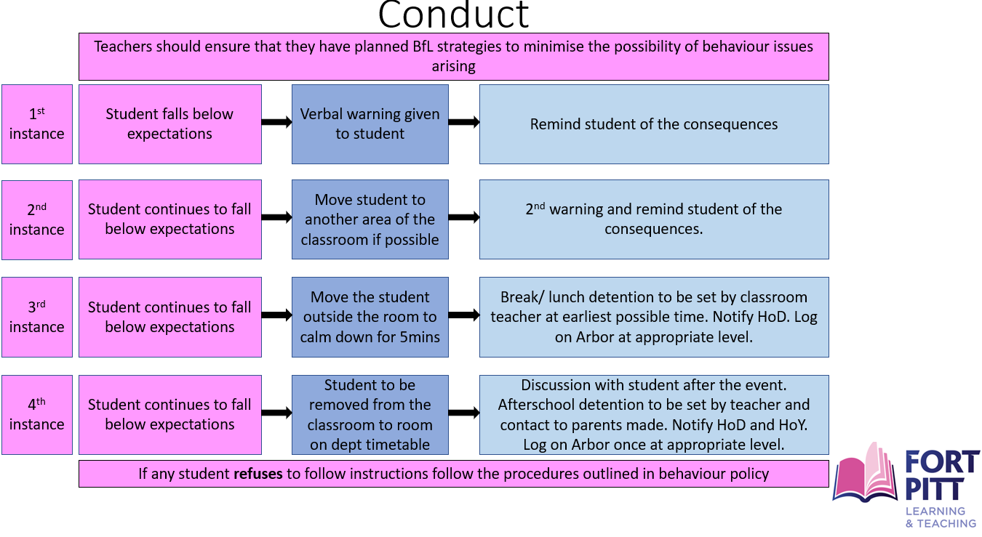

What does a detention look like?
Please see below for a list of appropriate tasks to be completed in a detention.

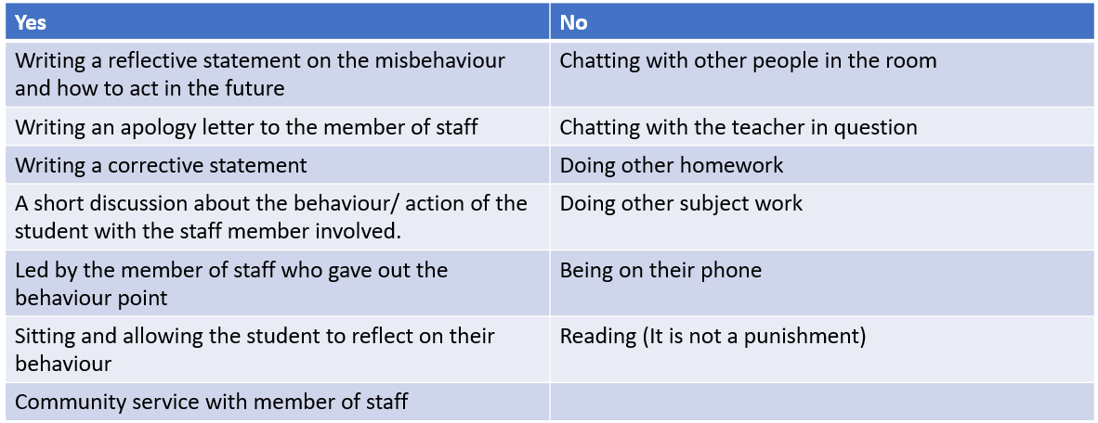

Other sanctions for non-compliance or unacceptable behaviour:
- HoD report for subject specific issues
- HoY Report for issues across subjects
- Loss of social time
- Isolation
- Internal suspension
- External suspension

Please see below for the condition within which the above would be set.

Persistent failure to comply with school rules or a one-off incident such as below, could result in an instant meeting with SLT and parents being invited in.
- Bringing, consuming or sharing illicit substances in school
- Damage to property
- Swearing at staff
- Theft
- Fighting
- Sexual harassment
- Racist behaviour
- Homophobic behaviour
- Bringing the school into disrepute
- Confrontational actions and/or language including swearing
- Smoking in school grounds or out of school in school uniform (including vaping and e-cigarettes)
- Bullying behaviour
- Persistent disrespectful behaviour

The school has a separate exclusions policy that follows the statutory guidance for exclusions set out by the Department of Education: https://www.gov.uk/government/publications/school-exclusion.

Training
The Local Governing Body and Headteacher will ensure that appropriate high-quality training on all aspects of behaviour management is provided on a regular basis, or as required by individuals, to support the implementation of this policy.

Inter-relationship with other school policies
In order for the Behaviour Management Procedures to be effective there has to be a clear relationship with other school policies. As such sanctions and rewards, anti-bullying and inclusive education procedures are available as policies in their own right. There are other policies that are mentioned in this document which can also be accessed on request.

Involvement of outside agencies
The school works positively with external agencies. It seeks appropriate support from them to ensure that the needs of all students are met by utilising the range of external support available.

Policy Review
The Deputy Headteacher (Wellbeing and Safeguarding), in consultation with the staff and school council, will undertake systematic monitoring and conduct regular reviews of the Behaviour Management Procedures in order to evaluate them to ensure that the operation is effective, fair and consistent. The Headteacher will keep the Local Governing Body informed.

The Local Governing Body will regularly review this policy and associated procedures, to ensure its continuing appropriateness and effectiveness. The review will take place in consultation with the Headteacher, staff, students and parents/carers.

The outcome of the review will be communicated to all those involved, as appropriate.

Search “without consent”

The school has the power to search without consent for “prohibited items” including:
- knives and weapons
- alcohol
- illegal drugs
- stolen items
- tobacco and cigarette papers
- vapes or e-cigarettes
- lighters
- fireworks
- any article that has been or is likely to be used to commit an offence, cause personal injury or damage to property; and
- any item banned by the school rules which has been identified in the rules as an item which may be searched for.

Legislation sets out what must be done with prohibited items found as a result of a search. Essentially – weapons, knives and suspected extreme or child pornography on a media device must always be handed over to the Police, otherwise it is for the Headteacher to decide if and when to return a confiscated item. No search is allowed of a media device without parents and/or police present.

Suspensions and Exclusions
For information about suspensions and exclusions, please see the suspension and exclusion policy.

Reports
Please see below for the different type of reports and the system of reporting.

HoDs/ HoY can instigate Tutor reports, HoD reports and HoY reports in the first instance due to lack of progress, poor behaviour or other general concerns.

